Lab Assignment #8
Space Satellite Modal and Radiation Analysis

EAE 133 - Finite Element Methods in Structures
Professor N. Sarigul-Klijn
TA: Noah Derita

Aurian Malhotra
920005606
Section A04, 11/20/2025

Introduction
The purpose of this lab was to extend the satellite model developed in Lab 7 by performing two additional finite element analyses: a modal analysis to determine the first ten natural frequencies and associated mode shapes, and a steady‑state thermal radiation analysis to evaluate temperature distribution throughout the structure. The satellite consists of a central cylindrical core with top and bottom covers and several external appendages. All surfaces were modeled using 2D shell elements, and the same material definitions and geometric layout from Lab 7 were retained.

A visualization of the overall satellite geometry, including the central core and external panels, was used to guide grouping, loading, and interpretation of results. The modal analysis captures the dynamic characteristics of the structure under launch constraints, while the thermal analysis represents radiative and conductive heat transfer due to electronics mounted on the central core.

Table 1: Thermal Conductivities for Satellite Materials
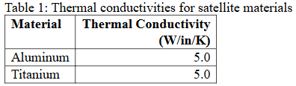

Figure 1: Thermal Properties for Idealized Satellite
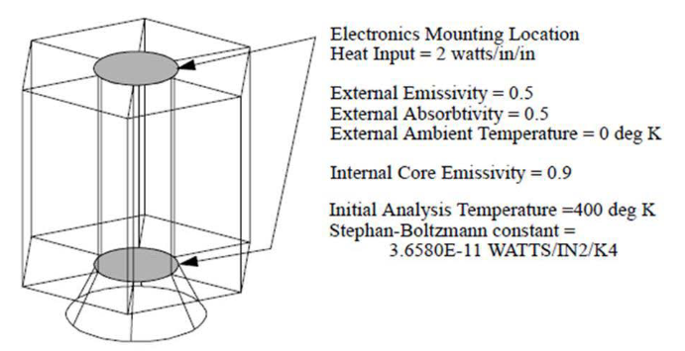

Procedure
The satellite geometry was imported directly from the previous lab and consisted entirely of surface bodies discretized using quad‑dominant shell elements. Aluminum and titanium materials were defined isotropically, each assigned thermal conductivity values of 5.0 W/in/K.

For the modal analysis, the model was constrained using the same launch boundary condition set applied previously. A Normal Modes solution was used with coupled mass formulation, and ten roots were requested to obtain the first ten natural frequencies. Eigenvector fringe and deformation plots were used to visualize each mode.

The thermal analysis required separating the geometry into two groups: the Central Core, which contains the heat‑generating electronics, and the External Surfaces, which radiate directly to space. A uniform heat flux was applied to the top and bottom ends of the central core to simulate electronics heating. Surface‑to‑surface enclosed radiation was assigned inside the cylinder, while external surfaces were subjected to ambient‑space radiation with emissivity and absorptivity values consistent with deep‑space exposure. A steady‑state thermal solution was then performed with an initial temperature of 400 K to obtain the final temperature distribution.

Results
The modal analysis produced the first ten natural frequencies and their corresponding mode shapes for the satellite.These frequencies reflect the inherent vibration characteristics of the structure under launch constraints. The first several modes primarily involve bending of the external appendages, while higher modes introduce more complex deformations involving the central core. Table 3 lists the ten natural frequencies, and the associated unique mode shapes are shown in Table 2.

Table 2: Plots of First Ten Unique Mode Shapes
Mode | Plot | Mode | Plot
1 | 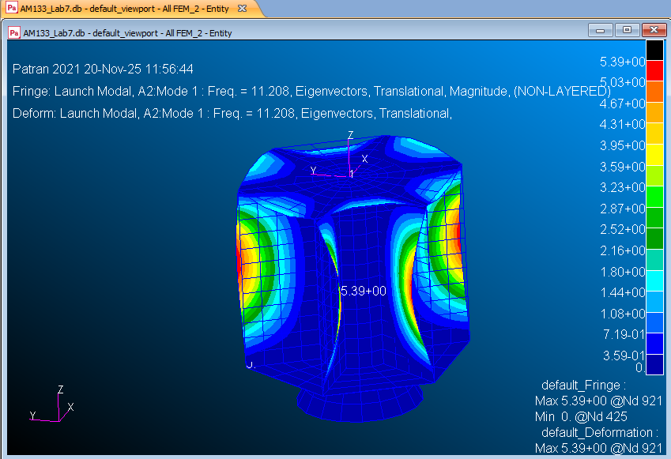 | 6 | 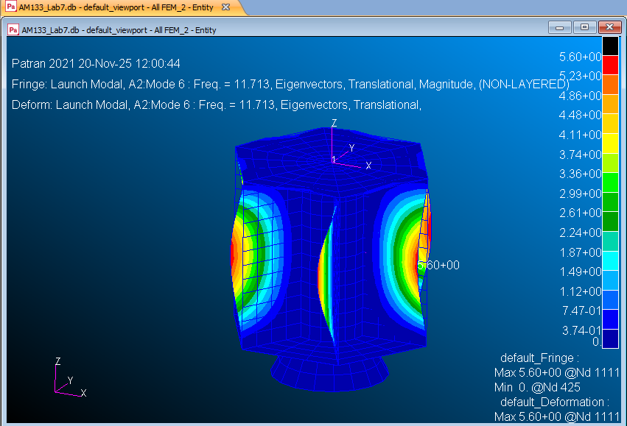
2 | 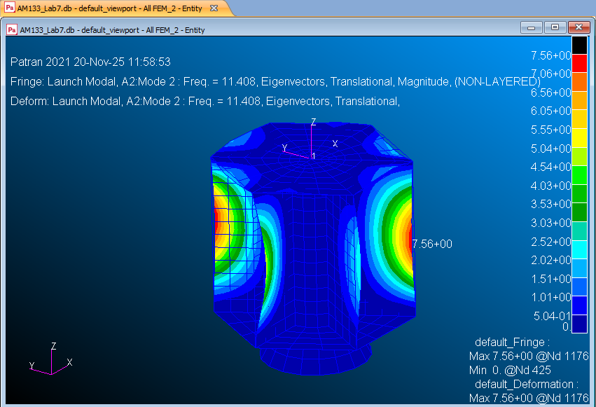 | 7 | 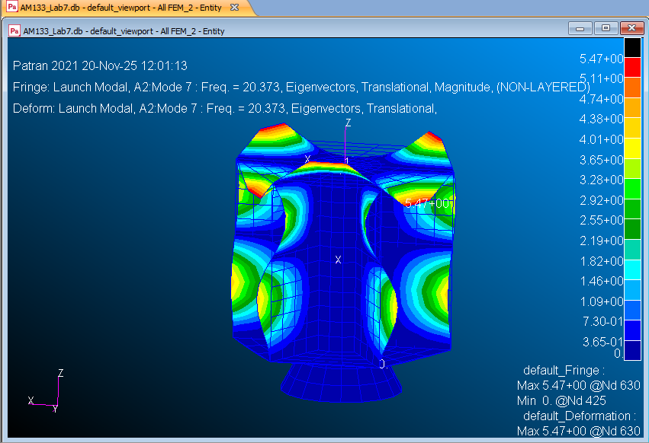
3 | 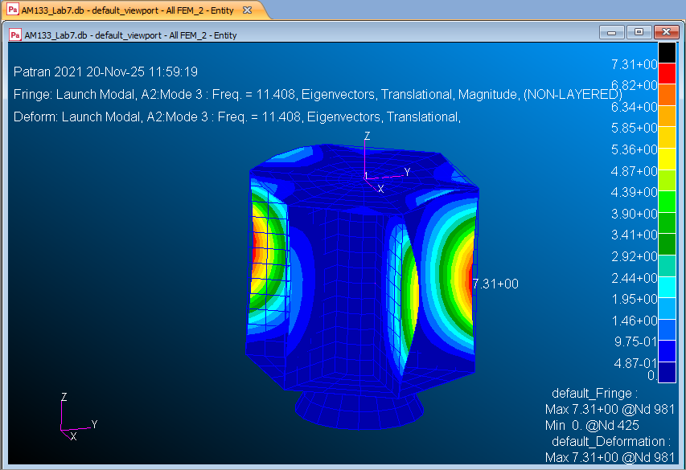 | 8 | 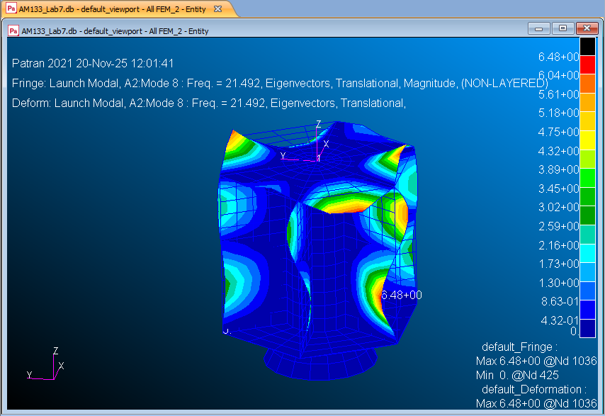
4 | 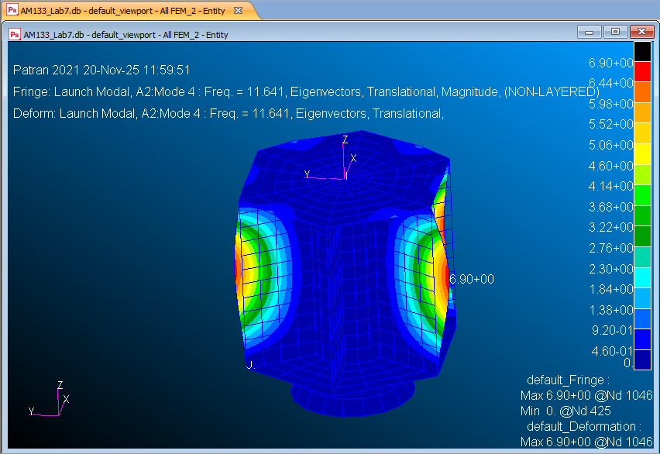 | 9 | 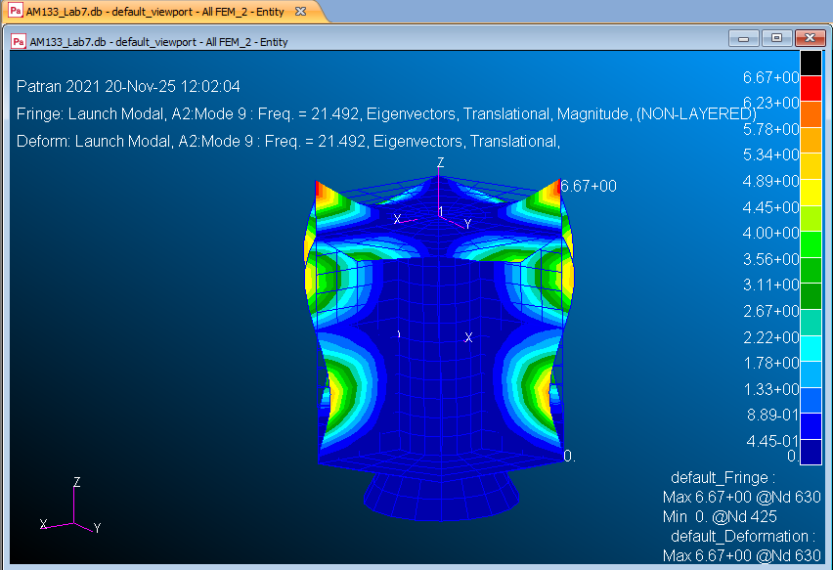
5 | 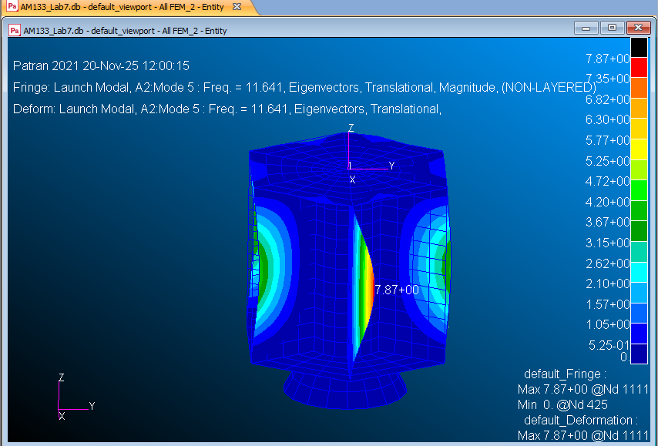 | 10 | 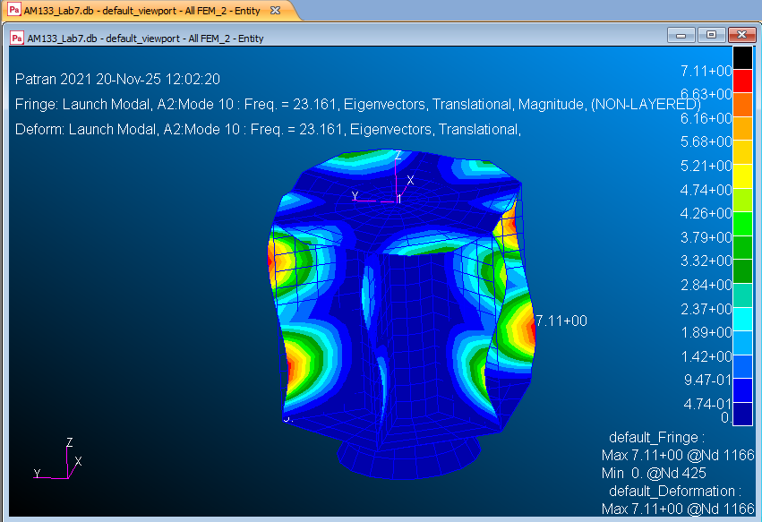

Table 3: First Ten Natural Frequencies
Mode | Frequency
1 | 11.208
2 | 11.408
3 | 11.408
4 | 11.641
5 | 11.641
6 | 11.713
7 | 20.373
8 | 21.492
9 | 21.492
10 | 23.161

The steady-state thermal analysis resulted in a non‑uniform temperature distribution driven by internal heat flux applied to the central core and radiative exchange with deep space. The highest temperatures occur at the core surfaces where heat is introduced, while the external panels cool significantly due to radiation.

Figure 2 shows the temperature field, and Table 4 summarizes the maximum and minimum temperatures across the satellite. Following the modal study, the analysis environment was switched to Thermal, and the model was re-grouped to isolate the central cylinder from the external surfaces. Internal heat flux (simulating onboard electronics) was applied to the cylinder ends, and three radiation conditions were assigned: enclosed radiation inside the central core, ambient space radiation for the central core outer surfaces, and ambient space radiation for top and bottom surfaces. Material thermal conductivities were set according to Table 1, with both aluminum and titanium assigned a value of 5.0 W/in/K. A steady‑state thermal solution was performed with an initial uniform temperature of 400 K.

Figure 2: Plot of Temperature Distribution
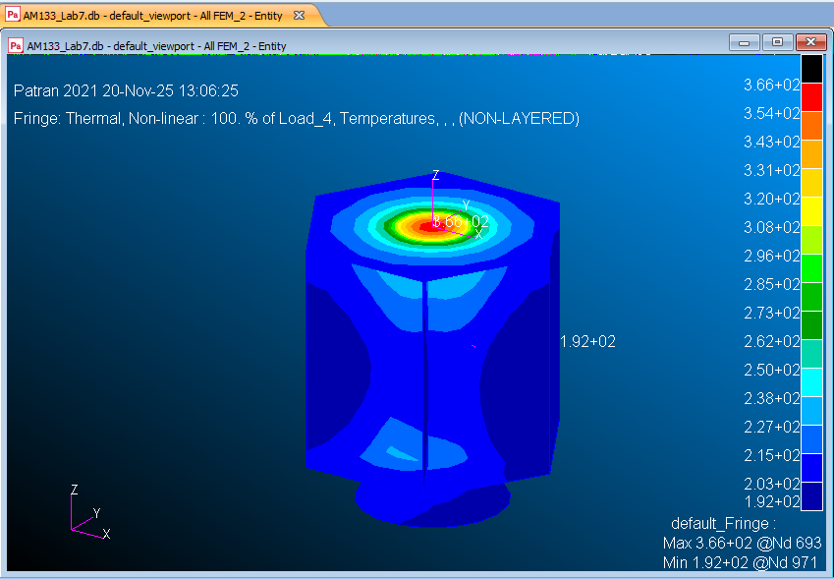

The resulting temperature field is shown in Figure 2. The central core reaches the highest temperature due to concentrated internal heat flux and limited radiative area. External surfaces, being directly exposed to ambient space radiation, cool significantly and approach the minimum temperature values.

Table 4: Minimum and Maximum Temperatures on Satellite (in Kelvin)
Maximum | 366 @ Node 693
Minimum | 192 @ Node 971

These results reflect expected thermal gradients: high temperatures in heat‑loaded central regions and lower temperatures at surfaces radiating to deep space.

Discussion/Conclusion
The modal analysis shows that the satellite’s vibrational response is dominated by bending modes in the solar panel structures. Symmetry drives paired frequencies, and higher modes involve central‑core deformation. These frequencies provide insight into potential resonant behavior during launch; ensuring that launch vehicle excitation frequencies do not coincide with these natural frequencies is essential for structural integrity.

The thermal analysis demonstrates significant temperature variation between the heat‑loaded core and external surfaces. Internal radiation and conduction distribute heat within the central cylinder, but limited conduction paths to the external panels result in higher core temperature. External surfaces radiate efficiently to space, resulting in much lower temperatures. These results emphasize the need for thermal management systems such as insulation, heat pipes, or increased coatings in real satellite designs.

Lab 8 successfully applied modal and thermal finite element analyses to the satellite structure originally developed in Lab 7. The modal study identified ten natural frequencies and associated deformation patterns, while the thermal study captured steady‑state radiation‑conduction interactions between internal electronics and deep‑space exposure. Together, these analyses demonstrate the versatility of finite element tools in predicting multiphysics behavior critical to satellite performance and reliability.

